ASSIGNMENT 5

Environmental sustainability. Carbon footprint
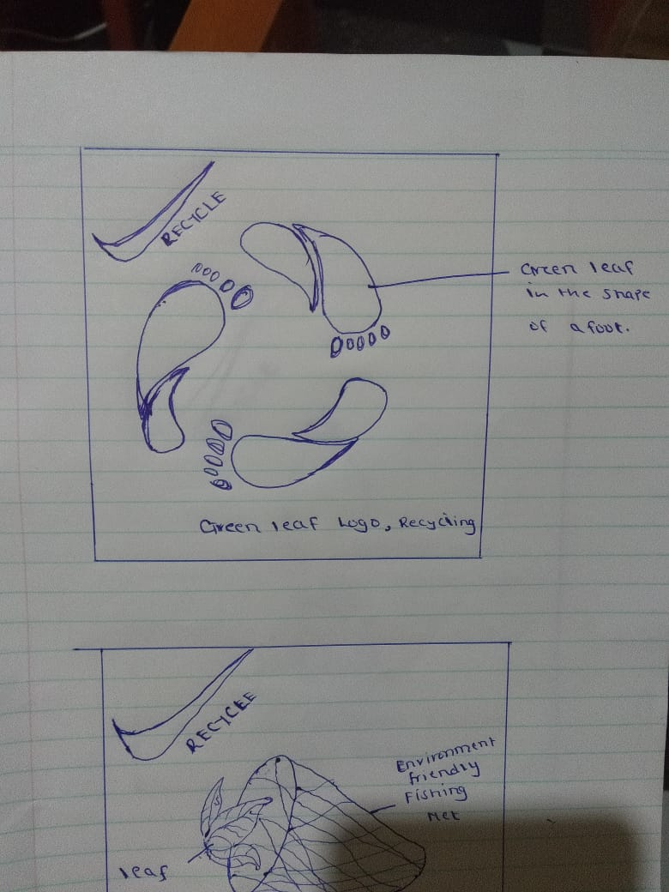

This is an eco-friendly Fishing Net.
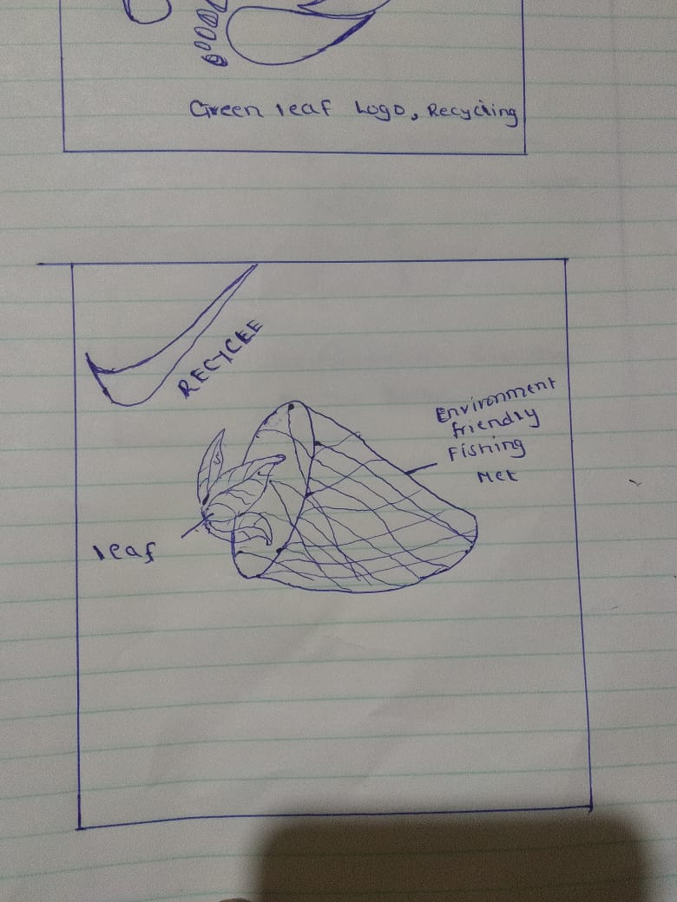

This is an eco-friendly bottle.
Bottle with Recycle Logo.
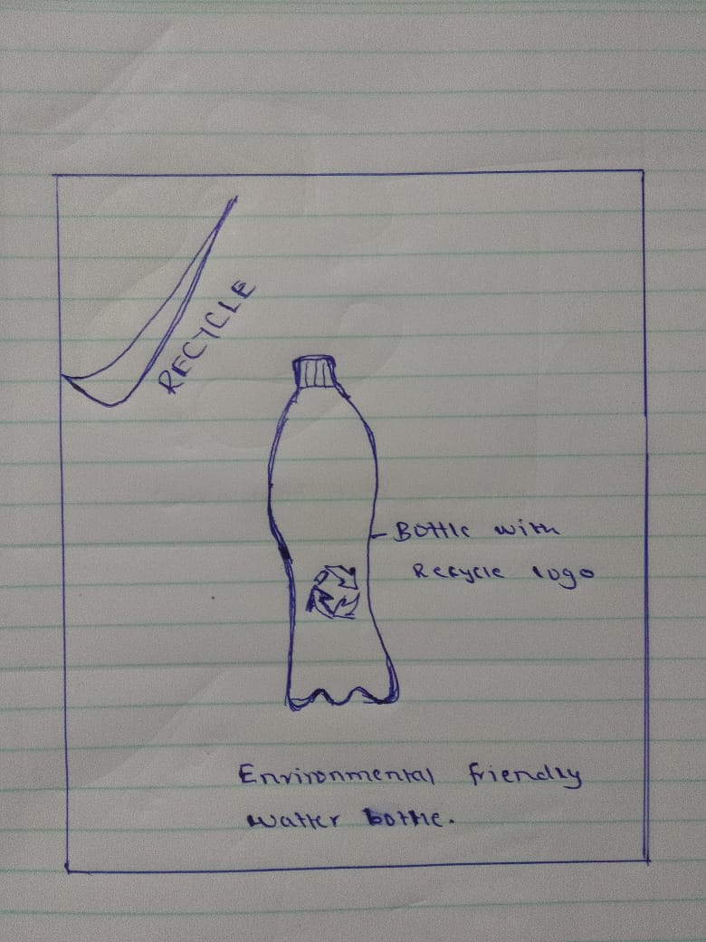

This is T-shirt with a recycling symbol.This indicates that we should use the environmental friendly products.
Recycle logo in aT-shirt. Eco-friendly T-shirt.
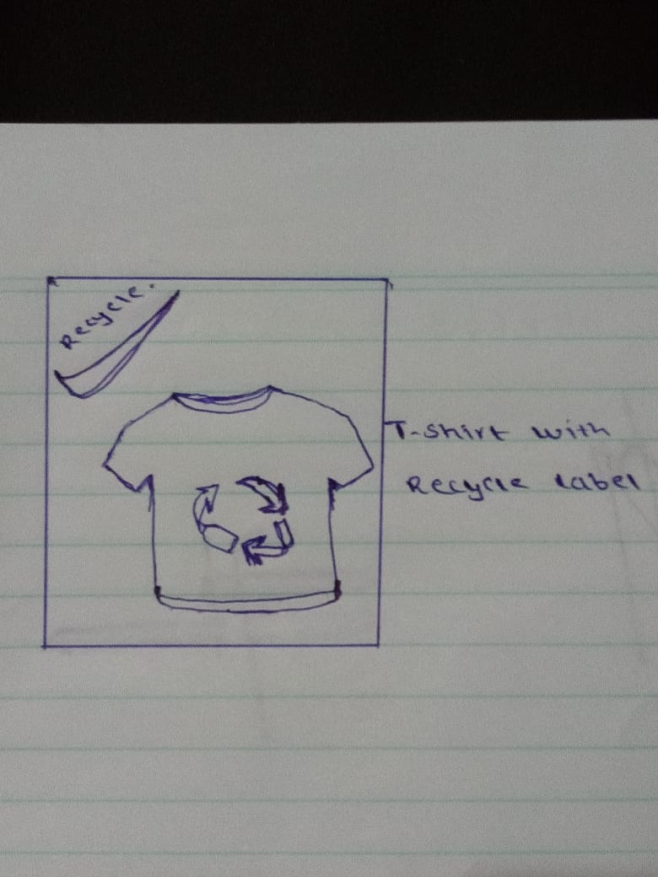

This is a symbol of giving direction made of wood which much environmental friendly compared to metals.
Environmental friendly symbol of direction.
